


TRAIN TICKET BOOKING APP

A PROJECT REPORT
Submitted by

MANIKANDAN. H (2303811710621061)

in partial fulfillment of requirements for the award of the course
EGB1221- DATABASE MANAGEMENT SYSTEMS
In
ELECTRONICS AND COMMUNICATION ENGINEERING

K. RAMAKRISHNAN COLLEGE OF TECHNOLOGY
(An Autonomous Institution, affiliated to Anna University Chennai and Approved by AICTE, New Delhi)

SAMAYAPURAM – 621 112

JUNE - 2025

K. RAMAKRISHNAN COLLEGE OF TECHNOLOGY
(AUTONOMOUS)
SAMAYAPURAM – 621 112

BONAFIDE CERTIFICATE

SIGNATURE  Dr.S.SYEDAKBAR, M.E., Ph.D.,  HEAD OF THE DEPARTMENT  ASSISTANT PROFESSOR  Department of ECE  K.Ramakrishnan College of  Technology (Autonomous)  Samayapuram–621112. | SIGNATURE  Mrs.R.BHAVANI, M.E., (Ph.D).,  SUPERVISOR  ASSISTANT PROFESSOR  Department of ECE  K.Ramakrishnan College of Technology (Autonomous)  Samayapuram–621112.
Certified that this project report on “ TRAIN TICKET BOOKING APP is the bonafide work of MANIKANDAN. H (2306811710621061)who carried out the project work during the academic year 2024 - 2025 under my supervision.

Submitted for the viva-voce examination held on …………….

INTERNAL EXAMINER EXTERNAL EXAMINER
VISION OF THE INSTITUTION
To serve the society by offering top-notch technical education on par with global standards

MISSION OF THE INSTITUTION
- Be a center of excellence for technical education in emerging technologies by exceeding the needs of the industry and society.
- Be an institute with world class research facilities
- Be an institute nurturing talent and enhancing the competency of students to transform them as all-round personality respecting moral and ethical values

VISION OF DEPARTMENT
To create innovative and socially responsible Electronics and Communication Engineers with design skills and research focus to meet Societal and Industrial needs.
MISSION OF DEPARTMENT
M1: To provide high quality education and professional ethics to students through enhanced learning environment.
M2: To impart a creative environment towards centre of excellence in department with design skill and exposure for research.
M3: To nurture required employable skills of students to satisfy the industry and social needs with ethical and human values.

PROGRAM EDUCATIONAL OBJECTIVES
PEO1: Core Knowledge Development: Graduates will have enhanced engineering skills in the field of electronics, communication and interdisciplinary areas to serve the society with global standards.
PEO2: Professional development: Graduates will apply the technical knowledge for continuous up gradation of their professional skills to become an inimitable employee, researcher or entrepreneur.
PEO3: Analytical Thinking: Graduates will have analytic and thinking skills to provide the innovative solutions for industry and societal requirements.
PROGRAM SPECIFIC OUTCOMES (PSOs)

PSO1: To analyze, design and develop solutions by applying foundational concepts of electronics and communication engineering.
PSO2: To apply design principles and best practices for developing quality products for scientific and business applications.
PSO3: To adapt to emerging information and communication technologies (ICT) to innovate ideas and solutions to existing/novel problems.
PROGRAM OUTCOMES (POs)
Engineering students will be able to:
- Engineering knowledge: Apply the knowledge of mathematics, science, engineering fundamentals, and an engineering specialization to the solution of complex engineering problems.
- Problem analysis: Identify, formulate, review research literature, and analyze complex engineering problems reaching substantiated conclusions using first principles of mathematics, natural sciences, and engineering sciences
- Design/development of solutions: Design solutions for complex engineering problems and design system components or processes that meet the specified needs with appropriate consideration for the public health and safety, and the cultural, societal, and environmental considerations
- Conduct investigations of complex problems: Use research-based knowledge and research methods including design of experiments, analysis and interpretation of data, and synthesis of the information to provide valid conclusions
- Modern tool usage: Create, select, and apply appropriate techniques, resources, and modern engineering and IT tools including prediction and modeling to complex engineering activities with an understanding of the limitations
- The engineer and society: Apply reasoning informed by the contextual knowledge to assess societal, health, safety, legal and cultural issues and the consequent responsibilities relevant to the professional engineering practice
- Environment and sustainability: Understand the impact of the professional engineering solutions in societal and environmental contexts, and demonstrate the knowledge of, and need for sustainable development
- Ethics: Apply ethical principles and commit to professional ethics and responsibilities and norms of the engineering practice.
- Individual and team work: Function effectively as an individual, and as a member or leader in diverse teams, and in multidisciplinary settings.
- Communication: Communicate effectively on complex engineering activities with the engineering community and with society at large, such as, being able to comprehend and write effective reports and design documentation, make effective presentations, and give and receive clear instructions.
- Project management and finance: Demonstrate knowledge and understanding of the engineering and management principles and apply these to one’s own work, as a member and leader in a team, to manage projects and in multidisciplinary environments.
- Life-long learning: Recognize the need for, and have the preparation and ability to engage in independent and life-long learning in the broadest context of technological change.
ABSTRACT
This project presents a Train Ticket Booking App designed to simplify and streamline the process of booking train tickets for passengers. The application allows users to search for available trains between stations, check schedules, view seat availability, and book tickets securely through a user-friendly interface. Key features include user authentication, real-time train tracking, fare calculation, e-ticket generation, booking history, and payment integration with various methods. The system is built to support both Android and iOS platforms, ensuring wide accessibility. The backend is designed to handle high traffic efficiently, maintain data integrity, and ensure secure transactions. This application aims to reduce the hassle of traditional ticket booking methods and enhance the overall user experience for rail travelers.view train schedules, check seat availability, and book tickets directly from their smartphones. It includes features such as user registration and login, booking history, fare details, and secure payment options. The application is designed with a user-friendly interface and ensures real-time updates on train availability and schedules. This system aims to reduce manual efforts, eliminate long queues at railway stations, and enhance the overall passenger experience by providing a seamless digital solution for train travel

ABSTRACT WITH POs AND PSOs MAPPING

CO 5 : BUILD DATABASE APPLICATIONS FOR SOLVING REAL-TIME PROBLEMS.
ABSTRACT | POs MAPPED | PSOs MAPPED
This project presents a Train Ticket Booking App designed to simplify and streamline the process of booking train tickets for passengers. The application allows users to search for available trains between stations, check schedules, view seat availability, and book tickets securely through a user-friendly interface. Key features include user authentication, real-time train tracking, fare calculation, e-ticket generation, booking history, and payment integration with various methods. | PO1 -3  PO2 -3  PO3 -3  PO4 -3  PO5 -3  PO6 -3  PO7 -3  PO8 -3  PO9 -3  PO10 -3  PO11-3  PO12 -3 | PSO1 -1  PSO2 -2  PSO3 -3

TABLE OF CONTENTS
CHAPTER NO. | TITLE | PAGE NO.
 | ABSTRACT | vi
1 | INTRODUCTION
 | 1.1 Objective | 1
 | 1.2 Overview | 2
 | 1.3 SQL and Database concepts | 2
2 | PROJECT METHODOLOGY
 | 2.1Proposed Work | 4
 | 2.2 Block Diagram | 5
3 | MODULE DESCRIPTION
 | 3.1 3.1 TRAIN &SEARCH | 6
 | 3.2SEAT SELECTION | 6
 | 3.3 BOOKING&PAYMENT | 6
 | 3.4 E TICKEt GENERATION | 6
 | 3.5 BOOKING TICKET MANAGEMENT | 7
4 | CONCLUSION AND FUTURE ENHANCEMENT | 8
5 | APPENDIX A SOURCE CODE | 10
 | APPENDIX B SCREEN SHOT | 10
 | REFERENCES | 11

CHAPTER 1

INTRODUCTION

Objective

The objective of this project is to develop a user-friendly mobile application that enables users to seamlessly search, book, and manage train tickets. The app aims to streamline the ticket booking process by providing real-time train schedules, seat availability, fare details, and secure payment options. It is designed to enhance user convenience, reduce manual effort, and improve the overall travel planning experience.

To design and develop a user-friendly mobile application for booking train tickets.

To provide real-time information on train schedules, routes, and seat availability.

To enable secure and convenient online ticket booking and cancellation.

To integrate multiple payment gateways for hassle-free transactions.

To offer users the ability to view and manage their booking history.

To reduce dependency on physical ticket counters and minimize wait time

Overview
The Train Ticket Booking App is a mobile-based application designed to simplify and digitize the process of booking train tickets. It provides users with an intuitive interface to search for trains, check availability, view schedules, and book tickets instantly. The app integrates real-time data from railway servers to ensure accuracy in train timings, seat availability, and fare details.

In addition to booking, the app allows users to cancel tickets, track train status, and access booking history. It supports multiple payment options, ensuring secure and flexible transactions. The app aims to reduce the reliance on physical booking counters, saving time for users and enhancing the efficiency of the railway ticketing system.

  - SQL and Database Concepts

1. Database Design (Schema Design)
Identify key entities: Users, Trains, Stations, Bookings, Tickets, Payments, Seats
Define relationships (e.g., one-to-many between Users and Bookings)

2. Normalization
Apply normalization techniques to reduce data redundancy and maintain data integrity (up to 3NF recommended)

3. SQL Tables and Relationships
Use Primary Keys for unique identification (e.g., user_id, train_id)
Use Foreign Keys to enforce relationships (e.g., user_id in Bookings table)

4. CRUD Operations

Create: Add new users, bookings, and train schedules
Read: Search trains, view booking status
Update: Modify bookings, user info
Delete: Cancel tickets or delete outdated related

CHAPTER 2
PROJECT METHODOLOGY

2.1Proposed Work
1. Requirement Analysis
Gather functional and non-functional requirements from users and stakeholders.
Identify system goals such as ease of booking, real-time updates, and secure transactions.
2. System Design
Design the application architecture including frontend, backend, and database layers.
Create an Entity-Relationship (ER) model to define relationships between entities like users, trains, tickets, and payments.
3. Database Development
Develop a normalized SQL database to store and manage data efficiency
Implement primary keys, foreign keys, and indexing for optimized performance.

2.2 Block Diagram

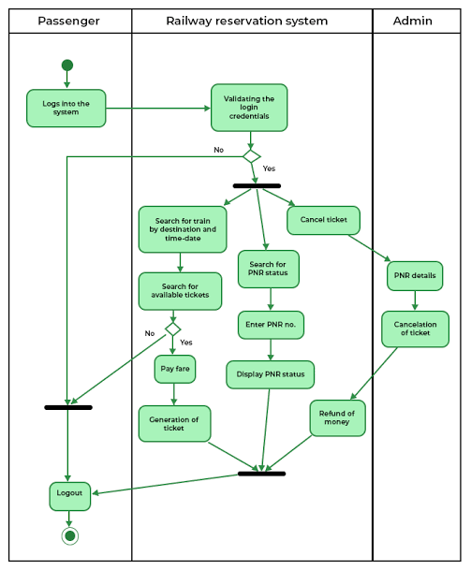

Fig 2.2.1 BlockDiagram

CHAPTER 3
MODULE DESCRIPTION

1. Train Search
Search trains by source and destination stations
Filter results by date, class, and train type
View train schedules, seat availability, and fare details

2. Seat Selection
View real-time seat availability
Select preferred seats and travel class (e.g., Sleeper, AC)

3. Booking & Payment
Input passenger details
Choose payment options (credit/debit cards, UPI, wallets)Secure paymentgateway integration

4. E-Ticket Generation
Instant generation of e-tickets after booking confirmation
Option to download or share ticket details via email

5. Booking History & Management
View past and upcoming bookings
Cancel or modify existing bookings as per policy

CHAPTER 4
CONCLUSION AND FUTURE ENHANCEMENT

The Train Ticket Booking App serves as a comprehensive solution for streamlining the process of searching, booking, and managing train tickets. With its user-friendly interface, real-time data integration, and secure payment system, it enhances the travel experience by providing convenience and efficiency for passengers. The app's features such as seat selection, e-ticket generation, and booking history management make it an indispensable tool for both frequent and occasional travelers.
1. AI-based Personalization:

Introduce AI-driven recommendations based on user travel history and preferences, such as suggested routes, seat preferences, or specific train timings.

2. Real-Time Train Tracking:

Enhance the app by integrating GPS-based real-time train tracking, providing users with up-to-the-minute information on train arrivals, delays, and train locations.

3. Multi-modal Travel Integration: Expand functionality to support multi-modal travel options, such as integrating buses, taxis, or metro services for door-to-door travel convenience
4. Offline Functionality:
Allow users to access their bookings, e-tickets, and other important details offline for areas with limited internet connectivity

APPENDIX A
import javax.swing.*;

import java.awt.*;

import java.awt.event.*;

class Train TicketBookingApp {

public static void main(String[] args) {

// Create the frame

JFrame frame = new JFrame(title: "Train Ticket Booking");

frame.setSize(width: 400, height: 400);

frame.setDefaultCloseOperation (JFrame.EXIT_ON_CLOSE);

frame.setLayout(new GridLayout(rows: 7, cols: 2, hgap: 10, vgap: 10));

// Create labels and text fields

JLabel nameLabel = new JLabel(text: "Passenger Name:");

JTextField nameField = new JTextField();

JLabel sourceLabel = new JLabel(text: "Source Station:");

JTextField sourceField = new JTextField();

JLabel destinationLabel = new JLabel(text: "Destination Station: ");

JTextField destinationField = new JTextField();

JLabel dateLabel = new JLabel(text: "Travel Date (dd-mm-yyyy):");

JTextField dateField = new JTextField();

JButton bookButton = new JButton(text: "Book Ticket");

JTextArea resultArea = new JTextArea();

resultArea.setEditable(false);

// Add components to the frame

frame.add(nameLabel);

frame.add(nameField);

frame.add(sourceLabel);

frame.add(sourceField);

frame.add(destinationLabel);

frame.add(destinationField);

frame.add(dateLabel);

frame.add(dateField);

frame.add(new JLabel()); // empty label for spacing

frame.add(bookButton);

frame.add(new JLabel(text: "Booking Info:"));

frame.add(resultArea);

// Add action listener to the button

bookButton.addActionListener(new ActionListener() {

public void actionPerformed(ActionEvent e) {

String name nameField.getText();

String source sourceField.getText();

String destination destinationField.getText();

String date dateField.getText();

if (name.isEmpty() || source.isEmpty() || destination.isEmpty() || date.isEmpty()) {

JOptionPane.showMessageDialog(frame, message: "Please fill all fields!", title: "Error", JOptionPane. ERROR_MESSAGE);

} else {

resultArea.setText("Ticket Booked!\n\n" +

"Name:" + name + "\n" +

"From: " + source + "\n" +

"To:" destination + "\n" +

"Date:" + date);

}

});

// Show the frame

frame.setVisible(true);

}

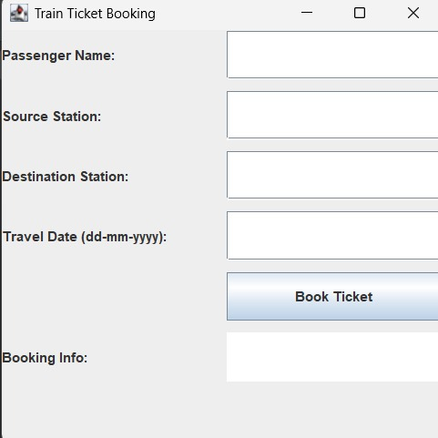
APPENDIX B

REFERENCES

- IRCTC Rail Connect:
- This is the official app by IRCTC and offers a comprehensive suite of features for train travel, including booking, PNR status checks, and train schedule information.
- IRCTC UTS:
- IRCTC UTS is a mobile application specifically designed for unreserved ticketing, allowing users to book and manage unreserved tickets directly from their smartphones, according to ConfirmTkt.
- ixigo Trains:
- ixigo Trains is a highly-rated app that provides a seamless experience for booking IRCTC train tickets.
- Trainman:
- Trainman is another popular app for train booking, offering features like train coach layouts, live train status, and PNR prediction.
- MakeMyTrip:
- MakeMyTrip is a well-known travel platform that also integrates with IRCTC for train ticket booking.
- Goibibo:
- Goibibo provides a convenient platform for booking train tickets and checking PNR status.

